D. Y. Patil College of College of Engineering and Technology, Kolhapur
Computer Science & Engg.

Subject – Advanced Programming Concepts
Assignment No. 13

Title of Mini-Project – Smart Attendances System Using Face Recognition

Description –

The AI-Based Smart Attendance System is a Python-based application that automates the attendance process using real-time face detection and recognition technology. The system captures live video through a webcam, detects faces, and compares them with previously registered facial encodings of authorized individuals. It uses the face_recognition library to generate 128-dimensional facial feature vectors and Euclidean distance matching with a configurable threshold of 0.6 to identify registered users.
The system displays a green bounding box for recognized individuals and a red bounding box for unknown faces. It also includes an anti-duplication mechanism to prevent the same person from marking attendance more than once per day. Attendance records are automatically stored in a CSV file containing the person's name, date, timestamp, and authorization status. OpenCV is used for webcam access and visual display, while NumPy and Pandas support face matching and attendance record management.
The project aims to reduce manual effort, improve attendance management efficiency, and provide a simple, locally operated attendance tracking solution for educational institutions and organizations.
Technology | Purpose
 | Main programming language
  Python
 | Webcam access, frame processing, and bounding boxes
  OpenCV
 | Facial feature extraction and identity matching
  Face Recognition
 | Euclidean distance calculations
  NumPy
 | Attendance record management
  Pandas
 | Saving and loading face encodings
  Pickle
CSV | Persistent attendance storage
dlib | Underlying face-recognition computations

Snapshots –
Snapshot 1: Live Face Recognition
Capture the running webcam window showing a registered person's face with a green bounding box
and name label.
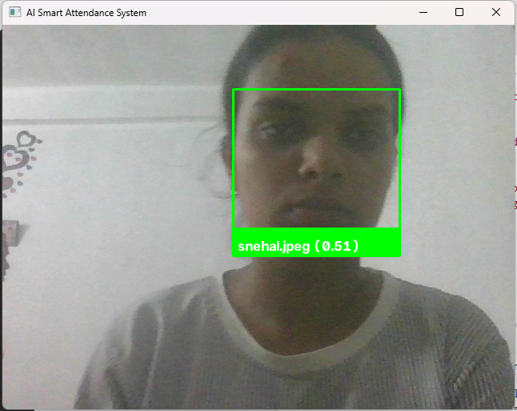
Snapshot 2: Unknown Face Detection
Show the webcam window detecting an unregistered face with a red bounding box and
an Unknown label.
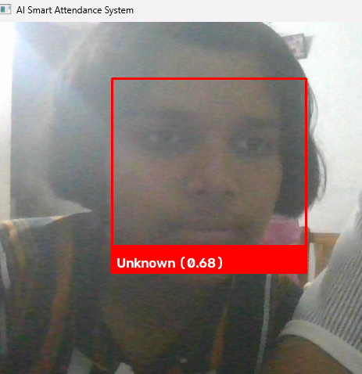

Snapshot 3: Attendance Records
Open attendance_records.csv in Excel or a spreadsheet viewer to show names, dates,
timestamps, and status.
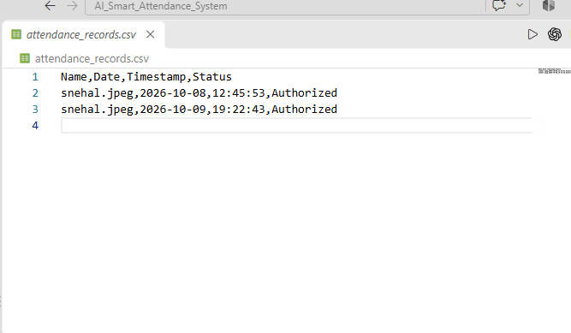

Date of Submission –

Juno Roll No | Name of Student | Sign
A10 | Snehal Ranjeet Dalavi

